CS 255 System Design Document

UML Diagrams

UML Use Case Diagram
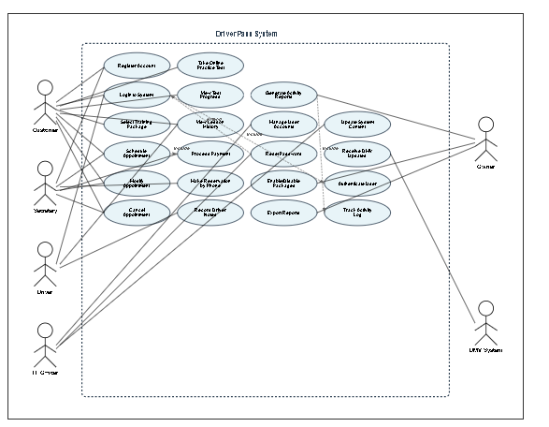

UML Activity Diagrams
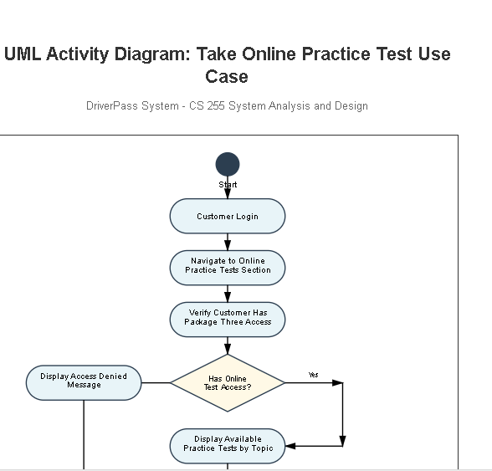
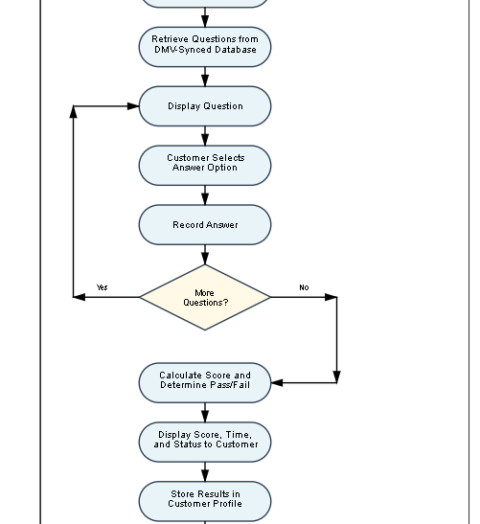
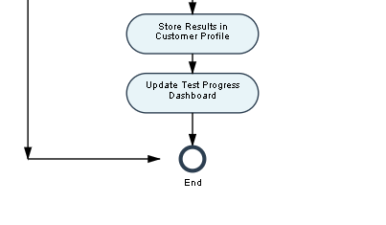
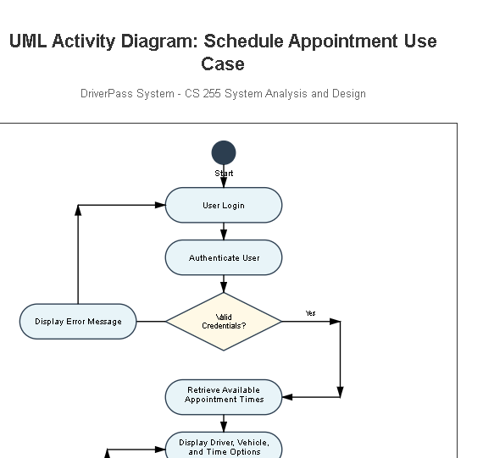
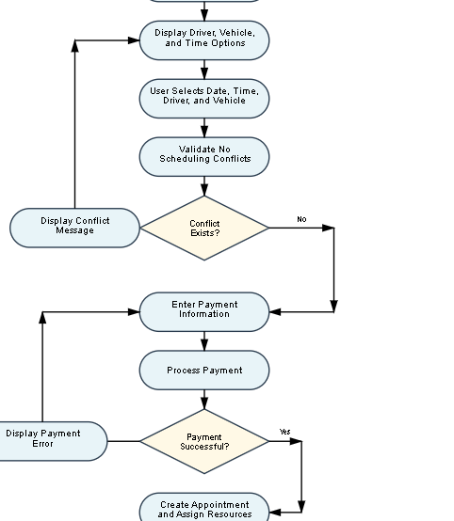
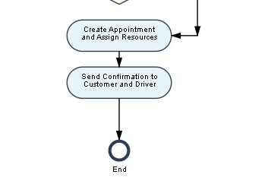

UML Sequence Diagram
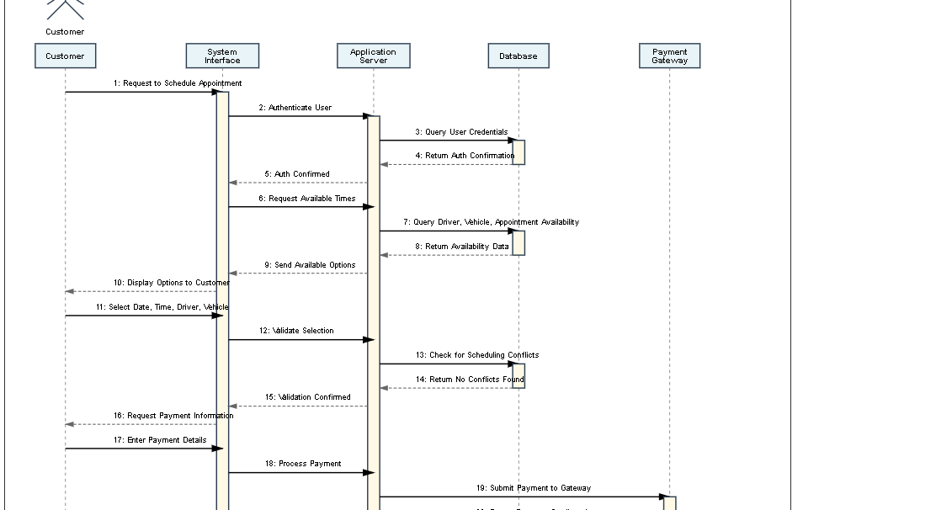
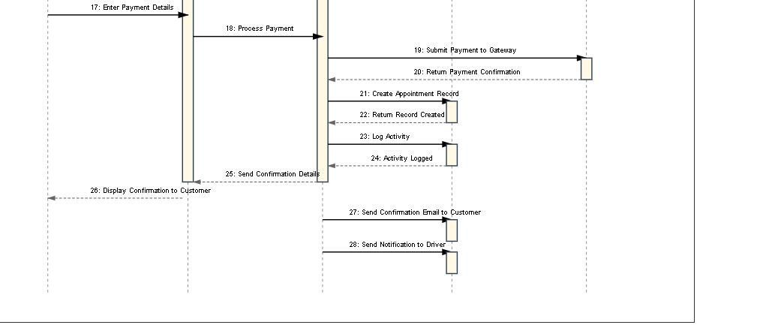

UML Class Diagram
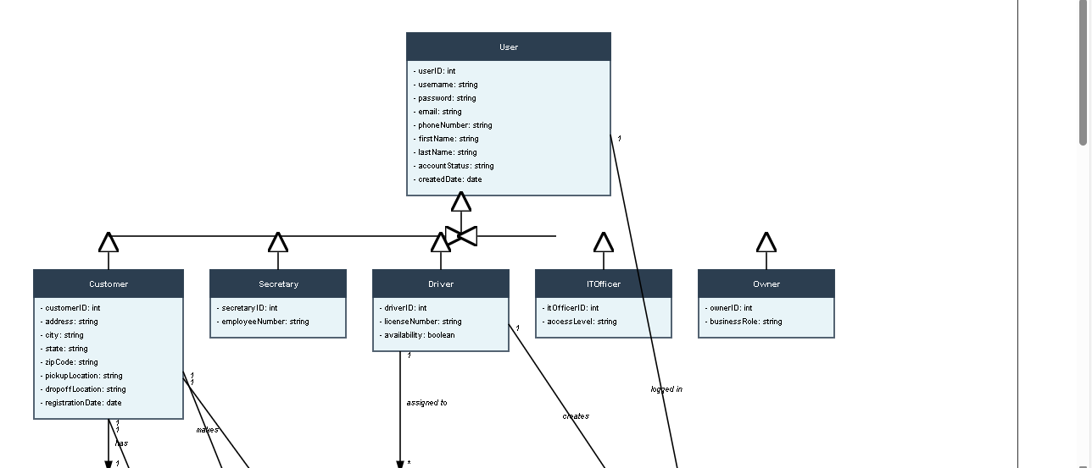
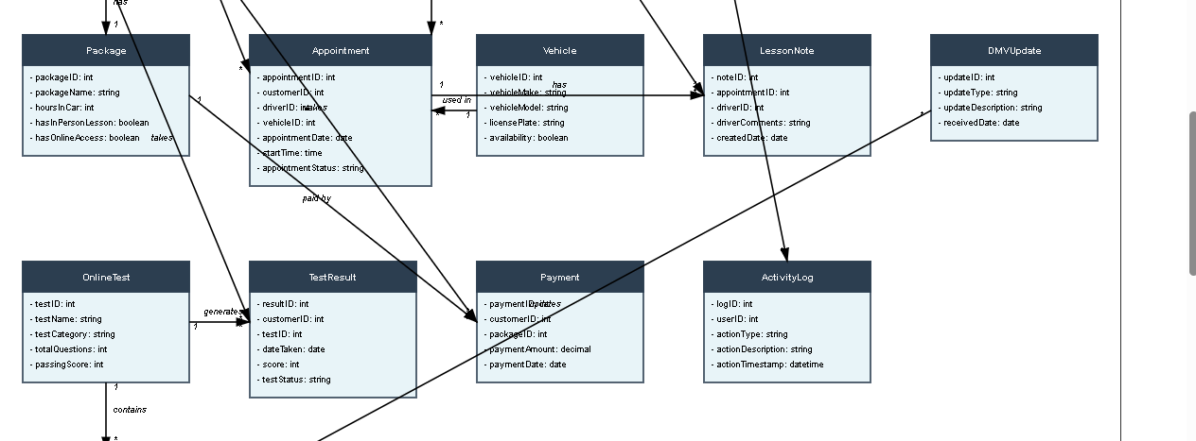
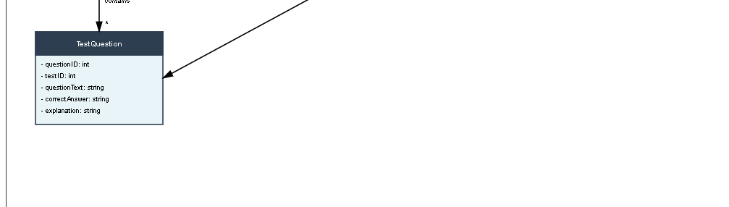

Technical Requirements
Hardware Requirements
The DriverPass system requires cloud-based infrastructure to support scalable operations and eliminate local hardware maintenance responsibilities as requested by the client. The production environment should utilize a minimum of two virtual server instances for load balancing and high availability. The web application server requires at least 16 GB RAM and four virtual CPU cores to handle concurrent user sessions during peak registration periods. The database server requires at least 32 GB RAM and eight virtual CPU cores to support real-time query processing and maintain response times under two seconds. Storage requirements include a minimum of 500 GB for the database with automatic scaling capabilities to accommodate growth in customer data, appointment records, test questions, and activity logs. An additional 200 GB of storage is required for application files, media content, and system backups. The infrastructure must support redundant storage with RAID configuration or equivalent cloud storage redundancy to prevent data loss.
Client-side hardware requirements are minimal given the web-based architecture. Customers require only a computing device capable of running modern web browsers, including desktop computers, laptops, tablets, or smartphones. The system must be responsive and functional on devices with at least 2 GB RAM and standard screen resolutions ranging from 320 pixels wide for mobile devices to 1920 pixels wide for desktop displays. Internet connectivity with minimum bandwidth of 5 Mbps is required for optimal performance when accessing online tests and streaming instructional content.
Software Requirements
The system requires a modern cloud infrastructure platform such as Amazon Web Services, Microsoft Azure, or Google Cloud Platform to provide infrastructure as a service capabilities. The operating system for server instances should be Linux-based, preferably Ubuntu Server LTS or Red Hat Enterprise Linux, to ensure stability and security. The web server software requires Apache HTTP Server or Nginx configured with SSL certificates to support HTTPS encrypted connections for all client-server communications.
The application layer requires a robust web application framework such as Java Spring Boot, .NET Core, or Node.js Express to implement the business logic and API endpoints. The database management system requires a relational database such as PostgreSQL, MySQL, or Microsoft SQL Server to store structured data including user accounts, appointments, test questions, and transaction records. Database configuration must support ACID transactions to maintain data integrity during concurrent operations.
The front-end requires modern web technologies including HTML5, CSS3, and JavaScript frameworks such as React, Angular, or Vue.js to create responsive user interfaces that adapt to various screen sizes and devices. The payment processing functionality requires integration with a PCI-DSS compliant payment gateway such as Stripe, PayPal, or Authorize.net to securely handle credit card transactions without storing sensitive payment information on DriverPass servers.
The system requires PDF generation libraries to create downloadable reports and receipts in compliance with the client requirement for Excel-compatible export functionality. Email service integration requires an SMTP server or cloud email service such as SendGrid or Amazon SES to deliver appointment confirmations, password reset links, and DMV update notifications to users and administrators.
Security software requirements include Web Application Firewall capabilities to protect against common web vulnerabilities, intrusion detection systems to monitor for suspicious activity, and encryption libraries to secure data at rest and in transit. The authentication system requires implementation of secure hashing algorithms such as bcrypt or Argon2 for password storage and JSON Web Tokens or session management middleware for maintaining authenticated user sessions.
Tools and Infrastructure Requirements
The development and deployment process requires continuous integration and continuous deployment tools such as Jenkins, GitLab CI/CD, or GitHub Actions to automate testing and deployment workflows. Version control requires Git repositories hosted on platforms such as GitHub, GitLab, or Bitbucket for source code management and collaboration among development team members.
The system requires API integration capabilities to connect with the DMV system for receiving automated updates to test questions, rules, and regulations. This integration may utilize REST API endpoints, SOAP web services, or secure FTP depending on the DMV technical infrastructure. The system must implement automated polling or webhook listeners to detect and process DMV updates promptly as emphasized in the client interview.
Monitoring and logging infrastructure requires application performance monitoring tools such as New Relic, Datadog, or Application Insights to track system performance, identify bottlenecks, and ensure two-second response time requirements are met. Centralized logging solutions such as ELK Stack (Elasticsearch, Logstash, Kibana) or Splunk are required to aggregate activity logs for security auditing and troubleshooting purposes.
Backup and disaster recovery infrastructure requires automated daily database backups with point-in-time recovery capabilities. Backup data must be stored in geographically separate data centers to ensure business continuity in case of regional outages. The recovery time objective should be less than four hours and the recovery point objective should be less than one hour to minimize data loss and downtime.
Load balancing infrastructure requires implementation of application load balancers to distribute incoming traffic across multiple server instances, ensuring high availability and preventing single points of failure. The system should support automatic scaling based on CPU utilization and request volume to handle peak loads during registration periods without performance degradation.
Content delivery network services such as Cloudflare or Amazon CloudFront are recommended to cache static assets including images, stylesheets, and JavaScript files, reducing server load and improving page load times for geographically distributed users. DNS management requires configuration with health checks and automatic failover capabilities to redirect traffic to healthy server instances in case of failures.
Testing infrastructure requires automated testing frameworks for unit testing, integration testing, and end-to-end testing of critical user workflows. Performance testing tools such as Apache JMeter or LoadRunner are required to validate system capacity and identify performance bottlenecks before production deployment. Security testing tools including vulnerability scanners and penetration testing frameworks are required to identify and remediate security vulnerabilities before launch.
The technical infrastructure must support role-based access control implementation with fine-grained permissions to ensure users can only access functionality appropriate for their role as Customer, Secretary, Driver, IT Officer, or Owner. The system requires session management capabilities with configurable timeout periods and the ability to force logout of compromised accounts as specified by the IT Officer requirements in the client interview.
All technical components must be selected and configured to support the 99.9 percent uptime service level agreement mentioned in the business requirements, ensuring DriverPass can focus on business operations rather than technical maintenance as explicitly requested by the client during the interview.

